**A Generic Scenario Analysis of End-of-Life Plastic Management: Chemical Additives – Figures and Data**

**John D. Cheaa,b, Kirti M. Yenkie a, Joseph F. Stanzione, III a, and Gerardo J. Ruiz-Mercadoc**

a Department of Chemical Engineering, Henry M. Rowan College of Engineering, Rowan University Glassboro, NJ, 08028, USA

b Oak Ridge Institute for Science and Education, hosted by Office of Research & Development, US Environmental Protection Agency, Cincinnati, OH 45268, USA

c Office of Research & Development, U.S. Environmental Protection Agency, Cincinnati, OH, 45268, USA and Chemical Engineering Graduate Program, University of Atlántico, Puerto Colombia 080007, Colombia

Corresponding Author: Gerardo J. Ruiz-Mercado

Email Address: [ruiz-mercado.gerardo@epa.gov](mailto:ruiz-mercado.gerardo@epa.gov)



**Figure 1.** Additive release mechanism of plastics in the environment. The red object represents chemical additives residing inside the pore of the polymer matrix.

**Figure 2.** Municipal solid waste (MSW) composition in 2018

**Figure 2 Data:**

|  |  |
| --- | --- |
| **Total Municipical Solid Waste Generated** | 292,360,000 tons |
| **Pollutant** | **Fraction of MSW** |
| **Misc. Inorganic Wastes** | 0.014 |
| **Other** | 0.016 |
| **Yard Trimmings** | 0.121 |
| **Food** | 0.216 |
| **Rubber, Leather, Textiles fraction** | 0.090 |
| **Wood fraction** | 0.062 |
| **Metals fraction** | 0.088 |
| **Glass fraction** | 0.042 |
| **Paper and Paperboard fraction** | 0.231 |
| **Plastics fraction** | 0.122 |

**Source:** US EPA, National Overview: Facts and Figures on Materials, Wastes and Recycling, <https://www.epa.gov/facts-and-figures-about-materials-waste-and-recycling/national-overview-facts-and-figures-materials>.



**Figure 3.** Plastic waste composition in the United States in 2018. The overall recycling rate equates to 8.4%. The main plastic waste includes polyethylene terephthalate (PET), high density polyethylene (HDPE), polyvinyl chloride (PVC), low density polyethylene (LDPE), polylactic acid (PLA), polypropylene (PP), polystyrene (PS), and other

**Figure 3 Data:**

|  |  |  |
| --- | --- | --- |
| **Plastic Types** | **Mass Generated (tons)** | **Mass Recycled (tons)** |
| PET | 5290000 | 910000 |
| HDPE | 6300000 | 560000 |
| PVC | 840000 | 0 |
| LDPE/LLDPE | 8590000 | 370000 |
| PLA | 90000 | 0 |
| PP | 8150000 | 50000 |
| PS | 2260000 | 20000 |
| Other Resins | 4160000 | 1110000 |

**Source:** US EPA, “Advancing Sustainable Materials Management: 2018 Tables and Figures - Assessing Trends in Materials Generation and Management in the United States,” United States Environmental Protection Agency, 2020.



**Figure 4.** Material flow analysis of the plastic and additive mass flow using the 2018 municipal solid waste data as a basis. The black arrow indicates the main material movement, the red arrow indicates release as litter and spillage, the orange dashed line indicates migration and contamination, and the green arrow indicates recycling.

**Figure 4 Data:**

**Chemical Contamination Data in Mechanically Recycled Plastics:**

|  |  |  |  |  |
| --- | --- | --- | --- | --- |
| **Chemicals found in PC plastic** | **PC HDPE Concentration (Approx μg/g)** | **% in PC HDPE** | **PC LDPE Concentration (Approx μg/g)** | **% in PC LDPE** |
| Contaminants | 30 | 0.003 | 100 | 0.01a |
| Polymer degradation products | 0 | 0 | 0 | 0 |
| Additive degradation products | 330 | 0.033 | 700 | 0.07b |
| Additives | 30 | 0.003 | 800 | 0.08b |

a. Contamination rate of 0.01% was chosen as it is the worst case scenario

b. Additive migration of 2% was used as a result of the % combination between additive degradation products and additives

**Source:** O. Horodytska, A. Cabanes and A. Fullana, Non-intentionally added substances (NIAS) in recycled plastics, *Chemosphere*, 2020, **251**, 126373.

**Litter Rate of 2%:**

**Source:** J. R. Jambeck, R. Geyer, C. Wilcox, T. R. Siegler, M. Perryman, A. Andrady, R. Narayan and K. L. Law, Plastic waste inputs from land into the ocean, *Science*, 2015, **347**, 768–771

**Specifically for the plastics EoL stages, refer to the generic scenario analysis in the main manuscript for the calculations**

**Mass reported on this figures were calculated using Assumptions from Table A1 of the Supplementary Information (SI).**

**Plastic Waste Trade Flows (2018) – Export and Import Data:**



|  |  |  |  |
| --- | --- | --- | --- |
| **Reported Plastic Import/Export (UNCOMTRADE 2018)** | | |  |
| **Plastic Types** | **Import (tons)** | **Export (tons)** | **Re-Export (tons)** |
| **Ethylene** | 139791 | 920477 | 7246 |
| **Vinyl Chloride** | 36647 | 137493 | 34 |
| **Styrene** | 19841 | 28071 | 27 |
| **Other Plastics** | 778806 | 543487 | 1038 |

**Source**: United Nations Department of Economic and Social Affairs Statistics Division. (HS code no. 391510, 391520, 391530, 391590). United Nations Commodity Trade Statistics Database, compiled for 2018. https://comtrade.un.org/data/

**The Fate of Plastic Wastes – Domestic and Exports:**

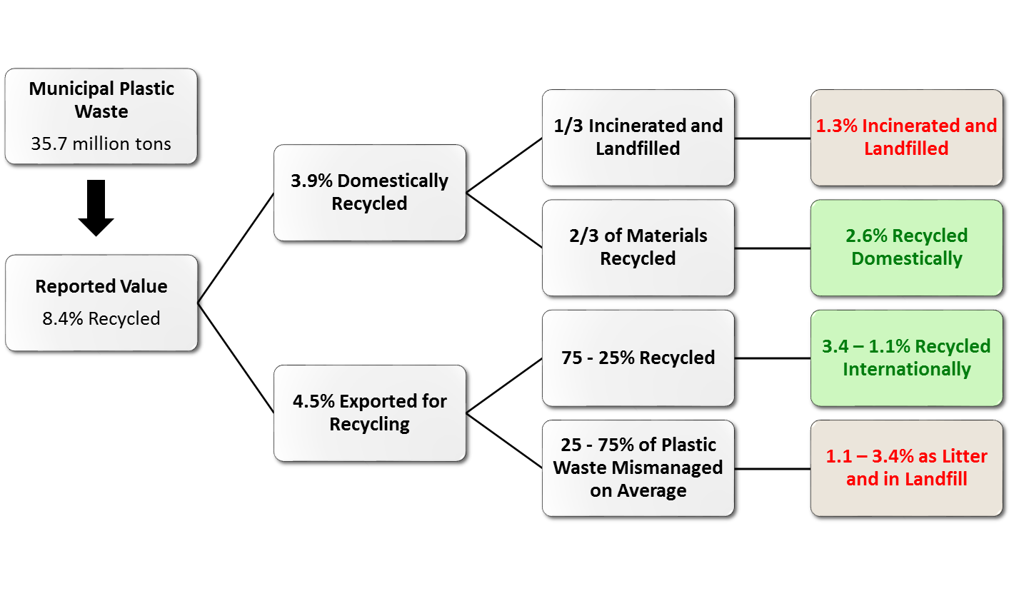

A study led by the University of Georgia researcher Jenna Jambeck found that Malaysia, the biggest recipient of US plastic recycling since the China ban, mismanaged 55% of its own plastic waste, meaning it was dumped or inadequately disposed of at sites such as open landfills. Indonesia and Vietnam improperly managed 81% and 86%, respectively. Overall, across all the countries, Jambeck concluded that between 25 – 75% of exports are mismanaged.

**Sources**: A. L. Brooks, S. Wang and J. R. Jambeck, The Chinese import ban and its impact on global plastic waste trade, *Science Advances*, 2018, **4**, eaat0131.

K. L. Law, N. Starr, T. R. Siegler, J. R. Jambeck, N. J. Mallos, and G. H. Leonard, “The United States’ contribution of plastic waste to land and ocean,” *Sci. Adv.*, vol. 6, no. 44, Oct. 2020, doi: [10.1126/sciadv.abd0288](https://doi.org/10.1126/sciadv.abd0288).

B. Messenger, “‘CarbonLITE Opens ‘World’s Largest’ Bottle-to-Bottle Recycling Plant in Pennsylvania,” *Waste Management World*, 2020. <https://waste-management-world.com/a/carbonlite-opens-world-s-largest-bottle-to-bottle-recycling-plant-in-pennsylvania>



**Figure 5.** The major material release routes during mechanical recycling



**Figure 6.** The incineration process and major material release routes

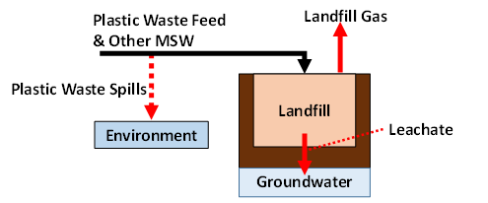

**Figure 7.** The major release routes in landfilling operation

**Figure 8.** Environmental footprints on the available resources. The total resource impact is equivalent to 373,056 m2.a/ton plastic recycled

**Figure 8 Data:**

|  |  |
| --- | --- |
| **Sustainable Process Index (SPI) Footprint Categories** | **Arable Area (m2.a)** |
| Water | 225,992 |
| Fossil Carbon | 115,877 |
| Soil | 15,635 |
| Air | 15,549 |
| Renewable | 0 |
| Non-Renewable | 0 |
| Land Area | 0 |

|  |  |  |
| --- | --- | --- |
| (a) Scenario 1 | (b) Scenario 2 | (c) Scenario 3 |
|  |  |  |

**Figure 9.** Sensitivity analyses of three hypothetical scenarios and their impacts on the total chemical additive release, greenhouse gas emissions, and energy footprint. (a) Scenario 1 examines the effect of increasing the rate of plastic recycling to the maximum technical feasbility limit; (b) Scenario 2 implements pyrolysis as a secondary plastic waste processing method, in addition to mechanical recycling; (c) Scenario 3 includes a chemical additive extraction stage before recycled plastics are sent to the manufacturing stage

Note: All values were calculated using Scenario 1, 2, and 3 – Material Flow Analysis Spreadsheet in the Sensitivity Analysis tab

**Figure 9a - Scenario 1 Data:**

|  |  |  |  |
| --- | --- | --- | --- |
| **Mechanical Recycling Rate (%)** | **Total Plastic Additive Release (tons)** | **Greenhouse Gas Emission (CO2-eq)** | **Energy Footprint (MJ)** |
| 0 | 0 | 0 | 0 |
| 3.8 | 56,341 | 7.12 · 106 | 1.50 · 1011 |
| 10.4 | 153,356 | 1.56 · 107 | 3.26 · 1011 |
| 20.4 | 300,349 | 2.85 · 107 | 5.93 · 1011 |
| 45.4 | 667,830 | 6.07 · 107 | 1.26 · 1012 |
| 65.4 | 961,815 | 8.64 · 107 | 1.80 · 1012 |
| 72.4 | 1,064,709 | 9.54 · 107 | 1.98 · 1012 |

**Figure 9b - Scenario 2 Data:**

|  |  |  |  |
| --- | --- | --- | --- |
| **Chemical Recycling Rate (%)** | **Total Plastic Additive Release (tons)** | **Greenhouse Gas Emission (CO2-eq)** | **Energy Footprint (MJ)** |
| 22.8 | 1,050,010 | 9.63 · 107 | 1.98344 · 1012 |
| 28.5 | 961,815 | 8.84 · 107 | 1.8208 · 1012 |
| 47.5 | 667,830 | 6.20 · 107 | 1.27866 · 1012 |
| 76 | 226,853 | 2.25 · 107 | 4.65446 · 1011 |
| 87 | 56,341 | 7.24 · 106 | 1.51004 · 1011 |
| 95 | 0 | 0 | 0 |

**Figure 9c - Scenario 3 Data:**

|  |  |  |  |
| --- | --- | --- | --- |
| **Additive Extraction Rate (%)** | **Total Plastic Additive Release (tons)** | **Greenhouse Gas Emission (CO2-eq)** | **Energy Footprint (MJ)** |
| 0 | 56,341 | 7.12 · 106 | 1.49594 · 1011 |
| 5 | 75,746 | 8.59 · 106 | 1.97034 · 1011 |
| 10 | 95,151 | 8.63 · 106 | 1.97246 · 1011 |
| 25 | 153,365 | 8.73 · 106 | 1.97882 · 1011 |
| 50 | 250,389 | 8.91 · 106 | 1.98943 · 1011 |
| 60 | 289,199 | 8.98 · 106 | 1.99367 · 1011 |
| 78 | 359,056 | 9.10 · 106 | 2.00131 · 1011 |
| 90 | 405,627 | 9.19 · 106 | 2.0064 · 1011 |

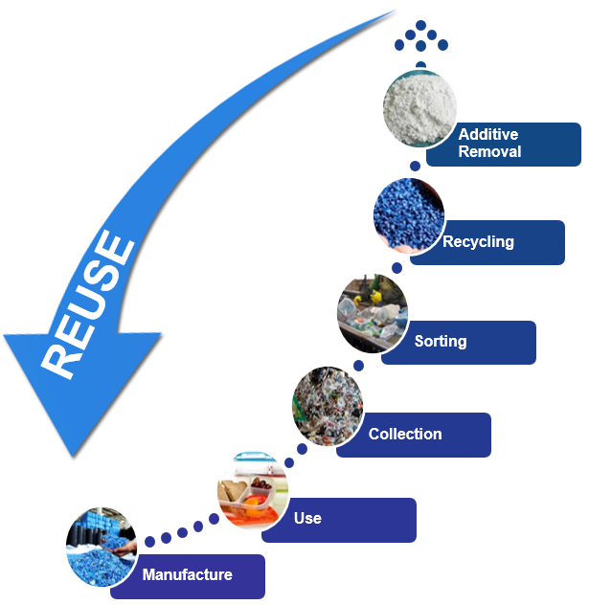

**Figure 10.** Proposed end-of-life (EoL) plastic waste management activities with chemical additive extraction

**C. Overall material flow analysis results for sensitivity analysis scenarios**

**Figure C1.** Scenario 1 – only utilizing mechanical recycling (the state of plastic wastes management in 2018)



**Data for Figure C1:**

For full calculation, please refer to Scenario 1 Spreadsheet “US Mat Flow Analysis 2018” tab.

|  |  |  |  |  |  |  |  |  |  |  |
| --- | --- | --- | --- | --- | --- | --- | --- | --- | --- | --- |
| **Stream** | **1** | **2** | **3** | **4** | **5** | **6** | **7** | **8** | **9** | **10** |
|  | [US tons] | [US tons] | [US tons] | [US tons] | [US tons] | [US tons] | [US tons] | [US tons] | [US tons] | [US tons] |
| **Total Mass** | 32,179,808 | 1,547,716 | 0 | 35,660,011 | 38,770 | 35,621,241 | 0 | 257,088,605 | 713,200 | 291,997,046 |
| **Total Plastics** | 32,179,808 | 0 | 0 | 33,724,199 | 159 | 33,724,040 | 0 | 402,649 | 674,106 | 33,452,583 |
| **Total Additives** | 0 | 1,547,716 | 0 | 1,935,812 | 38,611 | 1,897,201 | 0 | 23,113 | 38,695 | 1,881,619 |
| **Actual mass of emission (tons)** | 0 | 0 | - | 0 | 0 | 0 | - | 0 | 0 | 0 |
| **Total emissions (tons CO2 equivalent)** | 0 | 0 | 63,984,904 | 0 |  | 0 | 74,030,391 | 0 |  | 0 |
| **Emissions from Plastic (tons CO2 equivalent)** | 0 | 0 | 63,984,904 | 0 | 0 | 0 | 74,030,391 | 0 | 0 | 0 |

|  |  |  |  |  |  |  |  |  |  |  |
| --- | --- | --- | --- | --- | --- | --- | --- | --- | --- | --- |
| **Stream** | **11** | **12** | **13** | **14** | **15** | **16** | **17** | **18** | **19** | **20** |
|  | [US tons] | [US tons] | [US tons] | [US tons] | [US tons] | [US tons] | [US tons] | [US tons] | [US tons] | [US tons] |
| **Total Mass** | 28,892,160 | 118,990,520 | 43,025,761 | 65,970,900 | 0 | 1,367,592 | 0 | 3,192 | 136,075 | 1,932,487 |
| **Total Plastics** | 0 | 0 | 402,649 | 0 | 0 | 1,207,985 | 0 | 0 | 0 | 1,544,391 |
| **Total Additives** | 0 | 0 | 23,113 | 0 | 0 | 159,607 | 0 | 3,192 | 56,755 | 388,096 |
| **Actual mass of emission (tons)** | 0 | 0 | 0 | 0 | - | 0 | 0 | 0 | 0 | 0 |
| **Total emissions (tons CO2 equivalent)** |  |  |  | 0 | 120,151,790 | 0 | -1,330,003 | 0 | 0 | -1,939,365 |
| **Emissions from Plastic (tons CO2 equivalent)** | 0 | 0 | 0 | 0 | 120,151,790 | 0 | -1,330,003 | 0 | 0 | -1,939,365 |

|  |  |  |  |  |  |  |  |  |  |  |
| --- | --- | --- | --- | --- | --- | --- | --- | --- | --- | --- |
| **Stream** | **21 [Import]** | **22 [Re-Export]** | **23** | **24** | **25** | **26** | **27 [Export]** | **28** | **29** | **30** |
|  | [US tons] | [US tons] | [US tons] | [US tons] | [US tons] | [US tons] | [US tons] | [US tons] | [US tons] | [US tons] |
| **Total Mass** | 975,085 | 8,345 | 227,704 | 5,630,312 | 3,475 | 27,052,568 | 1,629,528 | 227,704 | 3,566,015 | 0 |
| **Total Plastics** | 746,554 | 7,889 | 201,130 | 5,357,168 | 556 | 25,740,159 | 1,439,147 | 201,130 | 3,372,420 | 0 |
| **Total Additives** | 228,531 | 456 | 26,575 | 273,145 | 30 | 1,312,408 | 190,381 | 26,575 | 193,595 | 0 |
| **Actual mass of emission (tons)** | 0 | 0 | 0 | 0 | 5,630,005 | 0 | 0 | 0 | 0 | 0 |
| **Total emissions (tons CO2 equivalent)** | 0 | 0 | 10,040 | 0 | 38,869,606 | 0 | 71,850 | 10,040 | 157,234 | 95,692,813 |
| **Emissions from Plastic (tons CO2 equivalent)** | 0 | 0 | 10,040 | 0 | 8,532,838 | 0 | 71,850 | 10,040 | 157,234 | 1,192,813 |

**Figure C2.** Scenario 2 – the combination of chemical and mechanical recycling



**Data for Figure C2:**

For full calculation, please refer to Scenario 2 Spreadsheet “US Mat Flow Analysis 2018” tab.

|  |  |  |  |  |  |  |  |  |  |  |
| --- | --- | --- | --- | --- | --- | --- | --- | --- | --- | --- |
| **Stream** | **1** | **2** | **3** | **4** | **5** | **6** | **7** | **8** | **9** | **10** |
|  | [US tons] | [US tons] | [US tons] | [US tons] | [US tons] | [US tons] | [US tons] | [US tons] | [US tons] | [US tons] |
| **Total Mass** | 32,179,808 | 1,547,716 | 0 | 35,660,011 | 38,770 | 35,621,241 | 0 | 257,088,605 | 713,200 | 291,997,046 |
| **Total Plastics** | 32,179,808 | 0 | 0 | 33,724,199 | 159 | 33,724,040 | 0 | 402,649 | 674,106 | 33,452,583 |
| **Total Additives** | 0 | 1,547,716 | 0 | 1,935,812 | 38,611 | 1,897,201 | 0 | 23,113 | 38,695 | 1,881,619 |
| **Actual mass of emission (tons)** | 0 | 0 | - | 0 | 0 | 0 | - | 0 | 0 | 0 |
| **Total emissions (tons CO2 equivalent)** | 0 | 0 | 63,984,904 | 0 |  | 0 | 74,030,391 | 0 |  | 0 |
| **Emissions from Plastic (tons CO2 equivalent)** | 0 | 0 | 63,984,904 | 0 | 0 | 0 | 74,030,391 | 0 | 0 | 0 |

|  |  |  |  |  |  |  |  |  |  |  |
| --- | --- | --- | --- | --- | --- | --- | --- | --- | --- | --- |
| **Stream** | **11** | **12** | **13** | **14** | **15** | **16** | **17** | **18** | **19** | **20** |
|  | [US tons] | [US tons] | [US tons] | [US tons] | [US tons] | [US tons] | [US tons] | [US tons] | [US tons] | [US tons] |
| **Total Mass** | 28,892,160 | 118,990,520 | 43,025,761 | 65,970,900 | 0 | 1,367,592 | 0 | 3,192 | 136,075 | 2,011,807 |
| **Total Plastics** | 0 | 0 | 402,649 | 0 | 0 | 1,207,985 | 0 | 0 | 0 | 1,544,391 |
| **Total Additives** | 0 | 0 | 23,113 | 0 | 0 | 159,607 | 0 | 3,192 | 56,755 | 388,096 |
| **Actual mass of emission (tons)** | 0 | 0 | 0 | 0 | - | 0 | 0 | 0 | 0 | 0 |
| **Total emissions (tons CO2 equivalent)** |  |  |  | 0 | 120,151,790 | 0 | -1,330,003 | 0 | 0 | -1,939,365 |
| **Emissions from Plastic (tons CO2 equivalent)** | 0 | 0 | 0 | 0 | 120,151,790 | 0 | -1,330,003 | 0 | 0 | -1,939,365 |

|  |  |  |  |  |  |  |  |  |  |  |
| --- | --- | --- | --- | --- | --- | --- | --- | --- | --- | --- |
| **Stream** | **21 [Import]** | **22 [Re-Export]** | **23** | **24** | **25** | **26** | **27 [Export]** | **28-P** | **28-I** | **28-L** |
|  | [US tons] | [US tons] | [US tons] | [US tons] | [US tons] | [US tons] | [US tons] | [US tons] | [US tons] | [US tons] |
| **Total Mass** | 975,085 | 8,345 | 455,408 | 281,516 | 2,978 | 1,352,628 | 1,629,528 | 432,638 | 3,923 | 18,848 |
| **Total Plastics** | 746,554 | 7,889 | 402,259 | 267,858 | 67 | 1,287,008 | 1,439,147 | 0 | 0 | 0 |
| **Total Additives** | 228,531 | 456 | 53,149 | 13,657 | 7 | 65,620 | 190,381 | 0 | 0 | 0 |
| **Actual mass of emission (tons)** | 0 | 0 | 0 | 0 | 281,500 | 0 | 0 | 0 | 0 | 0 |
| **Total emissions (tons CO2 equivalent)** | 0 | 0 | 20,080 | 0 | 30,763,410 | 0 | 7,452,169 |  | 10,075 | 173 |
| **Emissions from Plastic (tons CO2 equivalent)** | 0 | 0 | 20,080 | 0 | 426,642 | 0 | 7,452,169 | 113,351 | 10,075 | 173 |

|  |  |  |
| --- | --- | --- |
| **Stream** | **29** | **30** |
|  | [US tons] | [US tons] |
| **Total Mass** | 3,566,002 | 0 |
| **Total Plastics** | 3,372,420 | 0 |
| **Total Additives** | 193,582 | 0 |
| **Actual mass of emission (tons)** | 0 | 0 |
| **Total emissions (tons CO2 equivalent)** | 157,234 | 94,559,641 |
| **Emissions from Plastic (tons CO2 equivalent)** | 157,234 | 59,641 |

**Figure C3.** Scenario 3 – implementing chemical additive extraction stage post-mechanical recycling



**Data for Figure C3:**

For full calculation, please refer to Scenario 3 Spreadsheet “US Mat Flow Analysis 2018

|  |  |  |  |  |  |  |  |  |  |  |
| --- | --- | --- | --- | --- | --- | --- | --- | --- | --- | --- |
| **Stream** | **1** | **2** | **3** | **4** | **5** | **6** | **7** | **8** | **9** | **10** |
|  | [US tons] | [US tons] | [US tons] | [US tons] | [US tons] | [US tons] | [US tons] | [US tons] | [US tons] | [US tons] |
| **Total Mass** | 32,179,808 | 1,547,716 | 0 | 35,660,011 | 38,770 | 35,621,241 | 0 | 257,088,605 | 713,200 | 291,997,046 |
| **Total Plastics** | 32,179,808 | 0 | 0 | 33,724,199 | 159 | 33,724,040 | 0 | 402,649 | 674,106 | 33,452,583 |
| **Total Additives** | 0 | 1,547,716 | 0 | 1,935,812 | 38,611 | 1,897,201 | 0 | 23,113 | 38,695 | 1,881,619 |
| **Actual mass of emission (tons)** | 0 | 0 | - | 0 | 0 | 0 | - | 0 | 0 | 0 |
| **Total emissions (tons CO2 equivalent)** | 0 | 0 | 63,984,904 | 0 |  | 0 | 74,030,391 | 0 |  | 0 |
| **Emissions from Plastic (tons CO2 equivalent)** | 0 | 0 | 63,984,904 | 0 | 0 | 0 | 74,030,391 | 0 | 0 | 0 |

|  |  |  |  |  |  |  |  |  |  |  |
| --- | --- | --- | --- | --- | --- | --- | --- | --- | --- | --- |
| **Stream** | **11** | **12** | **13** | **14** | **15** | **16** | **17** | **18** | **19** | **20** |
|  | [US tons] | [US tons] | [US tons] | [US tons] | [US tons] | [US tons] | [US tons] | [US tons] | [US tons] | [US tons] |
| **Total Mass** | 28,892,160 | 118,990,520 | 43,025,761 | 65,970,900 | 0 | 1,367,592 | 0 | 3,192 | 136,075 | 1,932,487 |
| **Total Plastics** | 0 | 0 | 402,649 | 0 | 0 | 1,207,985 | 0 | 0 | 0 | 1,544,391 |
| **Total Additives** | 0 | 0 | 23,113 | 0 | 0 | 159,607 | 0 | 3,192 | 56,755 | 388,096 |
| **Actual mass of emission (tons)** | 0 | 0 | 0 | 0 | - | 0 | 0 | 0 | 0 | 0 |
| **Total emissions (tons CO2 equivalent)** |  |  |  | 0 | 120,151,790 | 0 | -1,330,003 | 0 | 0 | -1,939,365 |
| **Emissions from Plastic (tons CO2 equivalent)** | 0 | 0 | 0 | 0 | 120,151,790 | 0 | -1,330,003 | 0 | 0 | -1,939,365 |

|  |  |  |  |  |  |  |  |  |  |  |
| --- | --- | --- | --- | --- | --- | --- | --- | --- | --- | --- |
| **Stream** | **20-E** | **20-W** | **21 [Import]** | **22 [Re-Export]** | **23** | **24** | **25** | **26** | **27 [Export]** | **28** |
|  | [US tons] | [US tons] | [US tons] | [US tons] | [US tons] | [US tons] | [US tons] | [US tons] | [US tons] | [US tons] |
| **Total Mass** | 1,428,762 | 503,725 | 975,085 | 8,345 | 227,704 | 5,630,312 | 3,475 | 27,052,568 | 1,629,528 | 227,704 |
| **Total Plastics** | 1,389,952 | 154,439 | 746,554 | 7,889 | 201,130 | 5,357,168 | 556 | 25,740,159 | 1,439,147 | 201,130 |
| **Total Additives** | 38,810 | 349,286 | 228,531 | 456 | 26,575 | 273,145 | 30 | 1,312,408 | 190,381 | 26,575 |
| **Actual mass of emission (tons)** | 0 | 0 | 0 | 0 | 0 | 0 | 5,630,005 | 0 | 0 | 0 |
| **Total emissions (tons CO2 equivalent)** | 859,357 | 1,204,305 | 0 | 0 | 10,040 | 0 | 38,869,606 | 0 | 71,850 | 10,040 |
| **Emissions from Plastic (tons CO2 equivalent)** | 859,357 | 1,204,305 | 0 | 0 | 10,040 | 0 | 8,532,838 | 0 | 71,850 | 10,040 |

|  |  |  |
| --- | --- | --- |
| **Stream** | **29** | **30** |
|  | [US tons] | [US tons] |
| **Total Mass** | 3,566,015 | 0 |
| **Total Plastics** | 3,372,420 | 0 |
| **Total Additives** | 193,595 | 0 |
| **Actual mass of emission (tons)** | 0 | 0 |
| **Total emissions (tons CO2 equivalent)** | 157,234 | 95,692,813 |
| **Emissions from Plastic (tons CO2 equivalent)** | 157,234 | 1,192,813 |